# Exercise: Flexbox - Navigation

Create a web page like the following:

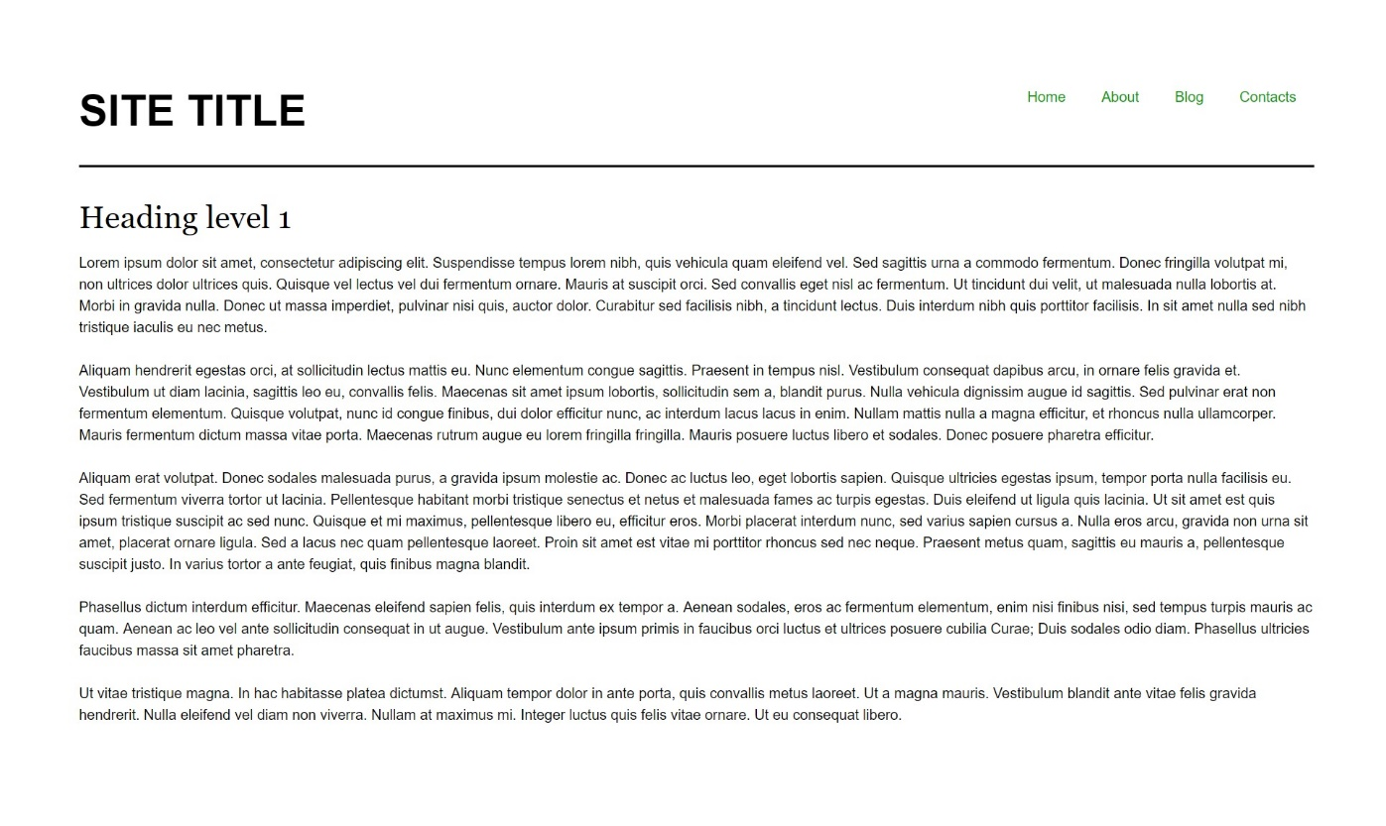

### Constraints

* Change the document title to "**Navigation - Flexbox**"
* Divide the body into header and main tag
* The underline in the header must have
  + Border width - 2px
  + Border color - rgb(0, 0, 0)
  + Border style - solid
* The display property of the header must be flex
* The unordered list in the header must have display property flex
* The anchors text color in the navigation must be rgb(0, 153, 0)